Mussaiyn Magzhan 170107185 A4

1

|  |  |  |  |  |
| --- | --- | --- | --- | --- |
| **Memory** | **# of addresses** | **# of data lines** | **# of address lines** | **Total # of bytes** |
| **1Mx4** | **1 048 576** | **4** | **20** | **0.5MB** |
| **2Mx8** | **2 097 152** | **8** | **21** | **2MB** |
| **1Kx8** | **1 024** | **8** | **10** | **1KB** |
| **2Kx16** | **2 048** | **16** | **11** | **4KB** |
| **4Gx32(*)** | **4 294 967 296** | **32** | **32** | **16GB** |

**2**

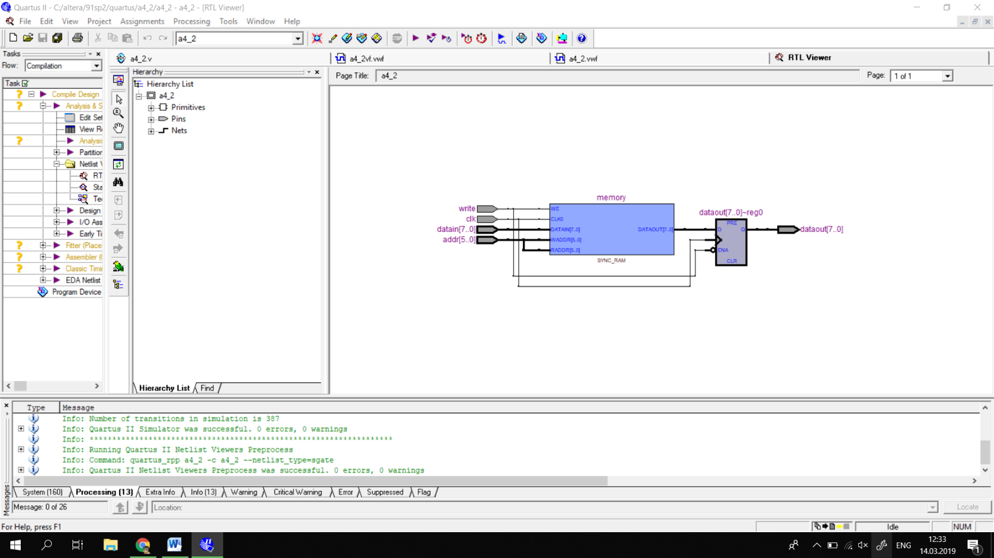

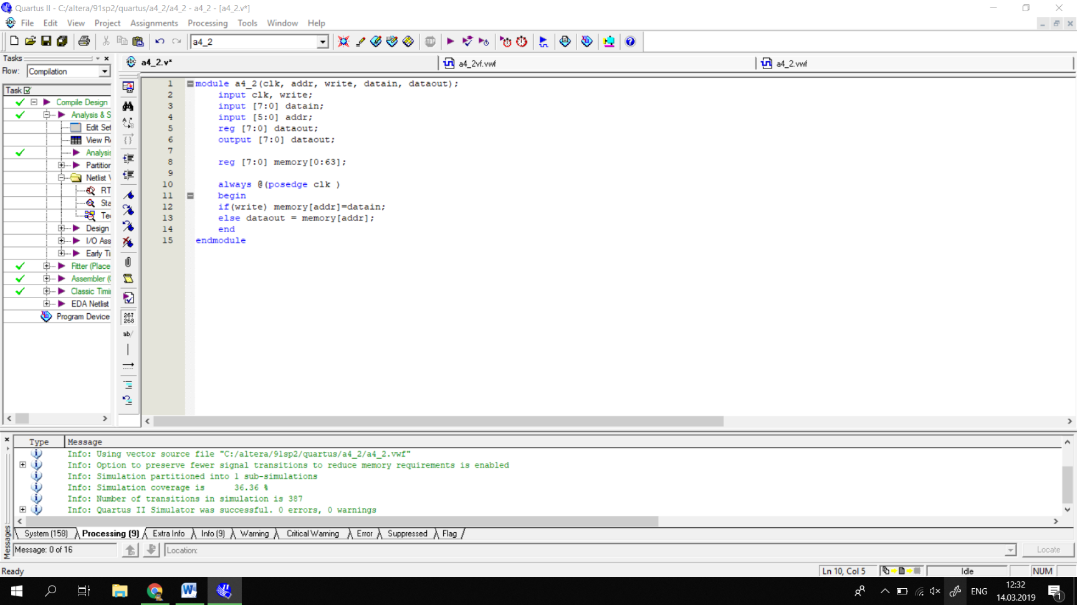

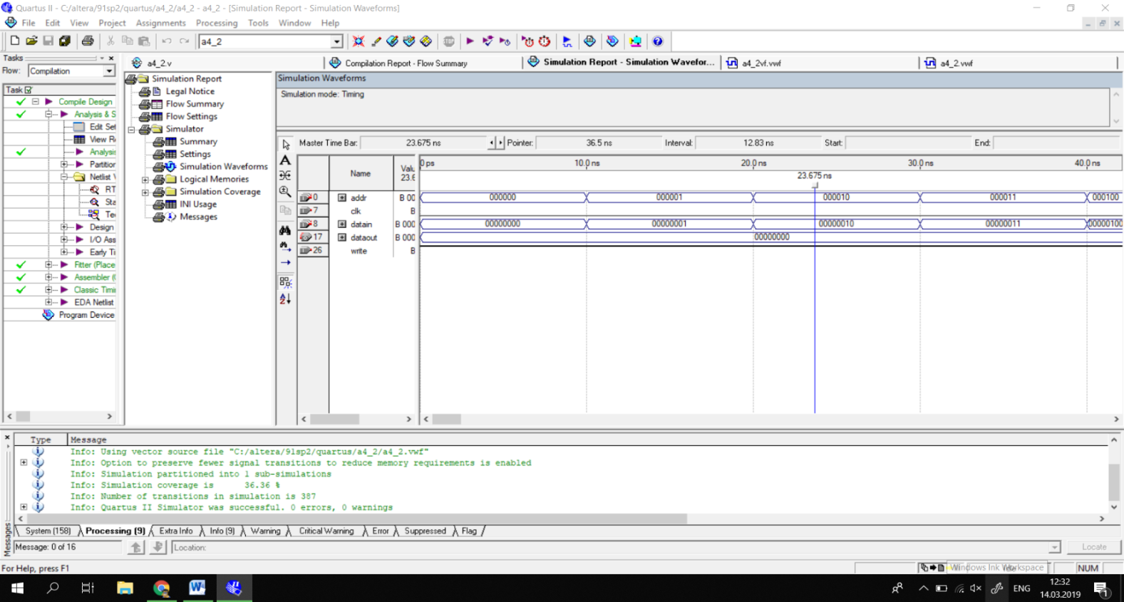

**3**

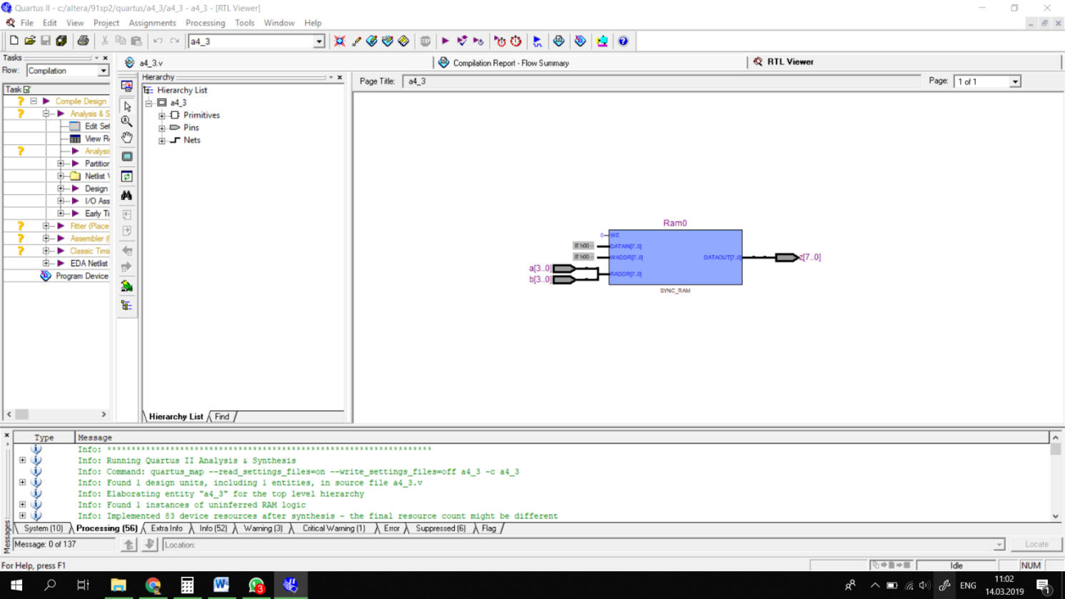

**Multiplication from 0*0 to 15*15**

